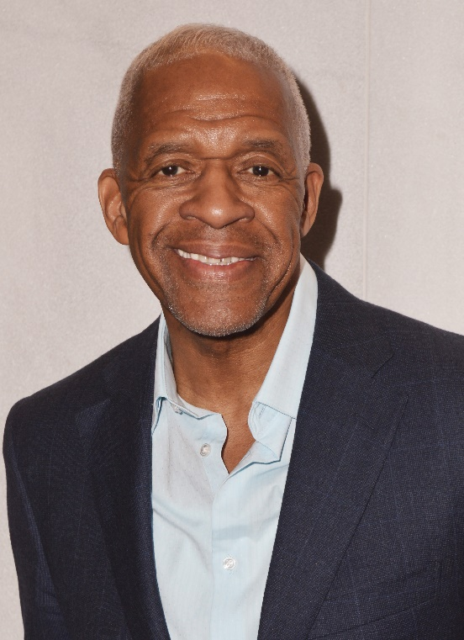
Reggie James is a social entrepreneur who founded the Harlem USA Map products initiative. He is a former healthcare marketing executive, as well as the founder of ReVision Inc., a private wellness coaching and training company. Most importantly he is a person in long term recovery. He has now opened ReVision House, a peer focused sober living residence that celebrates experiential value. As a Friends of Recovery (FOR-NY.org) best practice trainer, (BPT) under the umbrella of the NYS Office of Addiction Services and Supports (OASAS), he has dedicated his life work to uplifting those suffering from substance use disorder (SUD).
Reggie is devoted to breaking the social stigma associated with mental health issues and formerly incarcerated citizens, as well as the peer support professional workforce. He is an active member of various change agents throughout NYC including: Forward South Bronx Coalition (FSBC), Harlem’s Community Coalition on Mental Health (CCMH), NYC Department of Health and Mental Hygiene (DOHMH) Peer Coach Recovery Network (PCRN), Regional Peer Consortium Steering Committee and the OASAS NIDA Grant Stakeholder Group.
He is an original member and recently elected Chairman of Brothers in Recovery (BIR), a 31 year self-sustaining 501(c) (3) mutual aid organization. BIR is now developing an integrated peer workforce from their spiritual retreat and weekly support foundational model. Reggie is also founder/co-producer/host of their weekly public affairs/social justice radio show ‘Another Perspective,’ which airs from the campus of the City College of New York (CCNY) on WHCR 90.3 FM.
Reggie loves spending time with his wife and family on their spiritual evolvement. He enjoys holistic health, mind & body fitness, swimming, water sports and playing bridge. He thrives on real estate ventures that transform communities. Reggie is also a member of the Screen Actors Guild – American Federation of Television and Radio Artists (SAG-AFTRA), and served on the SAG Awards Nominating Committee in 2018. He is grateful for his support system of mentors, friends, colleagues and associates that guide him throughout his journey.

