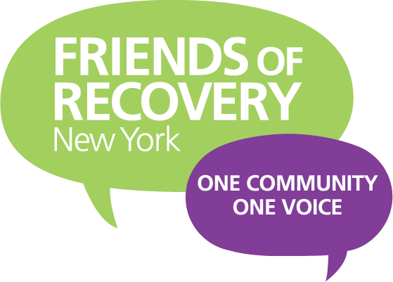 [Your Logo Here]
Press Conference and/or Rally Flyer
TUESDAY MAY 4 2021
Recovery Day of Action to Demand Opioid Settlement Dollars are put to Recovery, Prevention, Treatment and Harm Reduction Services and Supports

Thousands of New Yorkers have died, families devastated because Opioid manufacturers lied to consumers. Through herculean advocacy efforts of those left behind, Opioid manufacturers are now paying for their egregious actions. These funds MUST NOT GO TO FILL POTHOLES OR BUILD BRIDGES. These funds must be used to start to heal the communities which the addiction crisis has ravaged.
NOW WE NEED YOU
To Join Us for Rally (as part of a statewide day of action) demanding Opioid Settlement Dollars are put into addiction support services
Who: Recovery Champions, Family members who have lost loved ones, allies to the recovery movement from around NYS (Be specific about local organizations involved)
Where: (State the location you are having your rally)
What We Are Demanding:
- Settlement Dollars MUST BE PUT INTO A LOCKBOX
- The Office of Addiction Services and Supports (OASAS) should be the state agency that drives the conversation about how the dollars are spent- with serious input from those with lived experience
- Settlement dollars SHALL NOT be used to SUPPLANT existing funding

To RSVP or with Questions, Contact: (NAME, EMAIL, PHONE OF LEAD LOCAL ORGANIZER)

