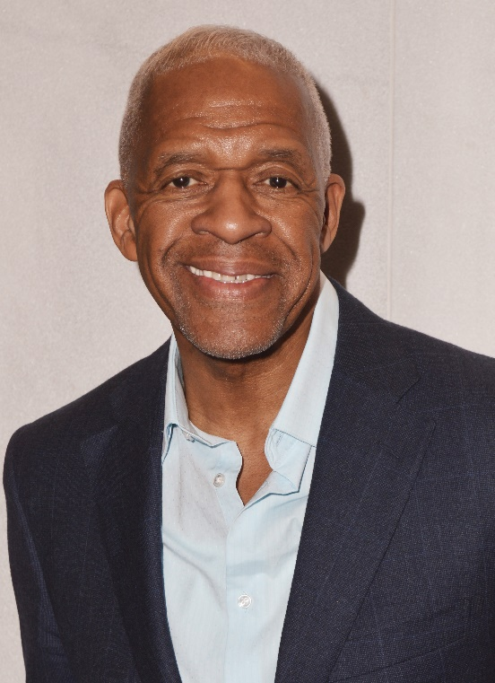
Reggie James is a social entrepreneur who founded the Harlem USA Map products initiative. He is a former not for profit healthcare marketing executive, as well as the founder of ReVision Inc., a private wellness coaching and training company. Most importantly he is a person in long term recovery. At the beginning of the Covid-19 pandemic he founded ReVision House LLC, to operate peer focused sober living residences that celebrate experiential value. As a Friends of Recovery (FOR-NY.org) best practice trainer, (BPT) under the umbrella of the NYS Office of Addiction Services and Supports (OASAS), he has dedicated his life work to uplifting those suffering from substance use disorder (SUD).
Reggie devotes himself to breaking the social stigma associated with mental health issues and formerly incarcerated citizens, as well as the peer support professional workforce. He is an active member of various change agents locally and nationally including Forward South Bronx Coalition (FSBC), Harlem’s Community Coalition on Mental Health, NYC Department of Health, and Mental Hygiene (DOHMH) Peer Coach Recovery Network (PCRN), Black Faces Black Voices and New Jersey Association of Mental Health and Addiction Agencies.
He is an original member and recent Board Chairman of Brothers in Recovery Inc., (BIR), a 34-year self-sustaining 501(c) (3) mutual aid organization. BIR began and continues as an annual spiritual retreat and added weekly support foundational meetings. Reggie is also founder/former co-producer/host of their weekly public affairs/social justice radio show ‘Another Perspective,’ which airs from the campus of the City College of New York (CCNY) on WHCR 90.3 FM.
Reggie loves spending time with his family and inner circle on their spiritual evolvement. He enjoys holistic health, mind & body fitness, swimming, water sports, cycling, theatre, music venues, playing bridge and travelling, especially throughout the African diaspora. He thrives on real estate ventures that transform communities. Reggie is also a member of the Screen Actors Guild – American Federation of Television and Radio Artists (SAG-AFTRA). He is grateful for his support system of mentors, friends, colleagues, associates, and ancestors that guide him throughout his journey.

