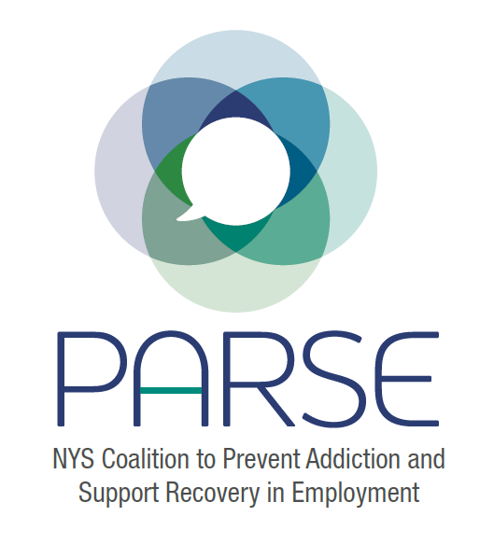

Full Coalition Meeting #7
- Updates:
  - Chose date for Symposium: Tuesday June 13 and Wednesday June 14, 2023 at Siena College in Albany, New York.
  - Still searching for funding support for symposium, any ideas please let us know
  - Interns working on podcasts, website, editorial, coalition member survey, policy work
  - Important new information to share:
    - New research paper: Workplace Supported Recovery from Substance Use Disorders: Defining the Construct, Developing a Model, and Proposing an Agenda for Future Research https://link.springer.com/article/10.1007/s41542-022-00123-x
    - New DOL Recovery Supportive Workplace Resource Hub: https://www.dol.gov/agencies/eta/RRW-hub/Recovery-ready-workplace
    - Surgeon General Advisory on Workplace mental health andwellbeing: https://www.hhs.gov/surgeongeneral/priorities/workplace-well-being/index.html
- NYS Opioid Settlement Board: Ashley Livingston, Board Member, Person with Lived Experience
  - Opioid Settlement Board based on legislation: https://www.nysenate.gov/legislation/bills/2021/S7870
  - Settlement board report released: https://oasas.ny.gov/system/files/documents/2022/11/osfab_yearly_report_110122.pdf
  - The recommendations include recovery and employment as well as workforce support
  - Funding will come in the form of requests for applications
  - Ashley is a person in recovery and has family connections to labor movement, understands the importance of workplace support in fighting addiction crisis
- Steering Committee Report: Kristen Chalmers (see notes here)
- Coalition Membership Survey: Cristina Dyer-Drobnack: will be shared soon and discussed in steering committee how we can incorporate feedback
- Policy Update: Jonathan Rosen: Notes from committee meeting are posted here References for policy work are here
- Breakout Groups:
  - Policy
    - Went through the current policy outline. Need to emphasize support from the White House and goals set by ONDCP in national drug control strategy. One of the 7 goals: “Advancing recovery-ready workplaces and expanding the addiction workforce.” From page 14: “Objective 1: The number of states operating a recovery-ready workplace initiative is increased 75-percent by 2025” .John Narine to share information from Colorado on incentives. Need to protect employee anonymity. Jonathan Rosen to schedule workgroup meeting.
  - Employer
    - Create an outreach letter, good stuff to start from on google drive. Creating sponsorship flyer with tiered sponsorship levels. Schedule subcommittee meeting to expand outreach plans including representatives from the coalition who work with employers. Cristina Dyer-Drobnack to schedule workgroup meeting.
  - Labor
    - Education is key with the labor unions. Brendan reported on Elevator Construction unions – 7 members died of overdose in one year leading to establishment of member assistance program. Numbers don’t lie and they have the data to show what works. Including aftercare in their pogram has led to an 80% success rate. Also discussed reaching out to building trades and state AFL-CIO to gain more labor involvement. Brendan could be a symposium speaker on how to develop member assistance programs.
  - Symposium Planning
    - Pre-conference institute to zone in on different areas (prevention, recovery, employment, labor, policy)
    - Keep agenda straight forward, don’t want to lose people, also want to keep people engaged. Power of the story. Shared definitions. Everyone feels on the inside. Opportunity to network and integrate.
Next meeting dates:
Upcoming meetings:
November 21 – Full Coalition
November 23 – Steering Committee
December 16 – Steering
Proposed following meetings
January
Full Coalition – Monday January 9
February
Steering Committee – Wednesday Feb 15
Full Coalition – Thursday Feb 23
March
Steering Committee –Wednesday March 1
Full Coalition – Tuesday March 7
April
Steering Committee – Wednesday April 5
Full Coalition – Monday April 10
May
Steering Committee – Wednesday May 10
Full Coalition – Tuesday May 16
June
Steering Committee – Wednesday June 7
Full Coalition – Thursday June 15
July
Steering Committee - Wednesday July 12
Full Coalition – Monday July 17
August
Steering Committee – Wednesday August 9
Full Coalition – Tuesday August 15
September
Steering Committee – Wednesday September 6
Full Coalition – Thursday September 14

35 people on call
Public Health (General)
Cristina Dyer Drobnack, NYSACHO, Public Policy and Program Director, cdyerdrobnack@nysacho.org
Emily D'Angelo, Program Manager at NYSACHO
Andrea Callahan, Livingston County DOH -acallahan@co.livingston.ny.us
Our of state
John Narine - RFW Colorado - john.narine88@gmail.com
University
Sarah Toledano, Siena College stoledano@siena.edu
NYS Government
OASAS
- Dean Hale, NYS OASAS dean.hale@oasas.ny.gov
- Brenda Harris-Collins, Director, Recovery Bureau, Division, Addiction Treatment and Recovery, New York State, Office of Addiction Services and Supports
DOH
- Michael Bauer, NYS Dept of Health
- Joanna Green, NYS Excelsior Fellow - NYS DOH AIDS Institute Office of Drug User Health. Joanna.green2@health.ny.gov

Addiction Recovery
Nydia Hill Crpa- CARC 518-479-9253
Ashley Livingston FOR-WW gettin2brighterdays@gmail.com
Theresa M Knorr, CARC RCP, Director of Recovery Education and Training, Friends of Recovery - NY tknorr@for-ny.org
Jess Ponti : Coordinator for The Central Region Addiction Resource Center jponti@bridges-mccasa.org 315-697-3947
Jessica Feliciano, Director, Recovery Services for Samaritan Daytop Village Jessica.feliciano@samaritanvillage.org
Patricia Benecke Assistant Director PARC Queens Recovery center, Samaritan Daytop Village patricia.benecke@samaritanvillage.org
Occupational Health and Safety
Jeanette Zoeckler - Director -- Occupational Health Clinical Center - zoecklej@upstate.edu
Janet Womachka-Souery, CSEA Occupational Safety & Health
Dan Vaughan-Cherubin, NENYCOSH, dvaughancherubin@nenycosh.org
Karl Auerbach MD, Staff Physician at OEHC of Eastern NY
Kristen Chalmers
Kitty Gelberg, epidemiologist and public health consultant, Kaygconsultingllc@gmail.com
Eric Persaud, NIEHS Clearinghouse for Worker Safety and Health Training
Kathy Ahlmark, NIEHS Clearinghouse for Worker Safety and Health Training
Jim Remington, NIEHS Clearinghouse for Worker Safety and Health Training
Labor
Brendan T Loftus local one iuec, NY NJ. director of member assistance/education program. bloftus@localoneiuec.com
Addiction Prevention
Milo Ward, Community Development Specialist NYC Prevention Resource Center, mward@childrensaidnyc.org
Alison Young - Healthy Workforce Network Coordinator for Alcohol & Drug Council of Tompkins County (in Ithaca NY) 607.274.6288 ayoung@alcoholdrugcouncil.org
Addiction Treatment
Ruth Riddick | ASAP
John Cappola, ASAP

