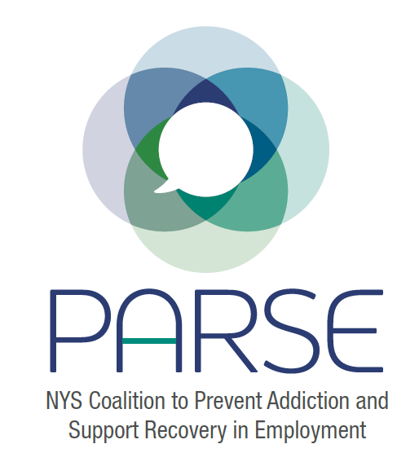

- PARSE updates
  - Administrative
    - Funding conversations: Unlikely to get funding until at least April. Looking to move symposium to Fall 2023.
    - Intern updates from past semester: worked on podcasts coming out soon, draft editorial developed
  - Research Committee update
Eric Persaud, Jeanette Zoekler: reached out to DOH in NY to gather data sets on mortality and morbidity, waiting to hear back from them, quietness due to holidays. Committee is capable at looking at other data streams.
Brought in intern- Mabel- MPH, epidemiology.
  - Symposium committee update (agenda): Agenda is being updated, will look for coalition members to review.
  - Education and Training committee update
Carrie Dunn-Herrera: Robust discussion talked about what is currently available. See notes from meeting in google drive.
  - Policy Committee update
Cristina Dyer-Drobnack- Jonathan put together a draft. Tuesday Jan 24-next policy committee meeting. We do not have bill sponsors yet.

- Reintroductions:
  - Name
  - Organization
  - What brings you here?
  - What are your goals for PARSE, what do you hope to get out of PARSE?

Ariana Williamson- Advisor, North Carolina, doing a lot of the same things in NC, forming subcommittees, applying for funding
Dr. Smith Wilson FOR-NY– New policy director by Feb 20. FOR-NY will be one of the fiduciaries for funding.
Jeanette Zoeckler Occupational Health Clinic Network (OHCN): - patients come and have problems with opioids, not enough is happening for them. See urgent need to get these issues addressed. Workforce is spread thin. Have heart for doing the research. NYS DOH- research that will push the legislation. Appreciates organizing efforts, feels connected to the coalition. Outreach is a natural support OHCN could provide.
Kristen Chalmers OHCN Finger Lakes - 3 days a week as a social worker. Work is giving meaning and purpose. Access to work, resilience and work stress, fatigue. Loves work of PARSE. Private therapist, EAP.
Nydia Hill- New Choices in Montgomery County/FOR-NY Board- lack of help Hispanic community receives where they work, not same pay, work conditions not in writing. If Hispanic workers call out, let go, punished. Goal for Hispanic community to receive equal opportunities and it doesn’t happen. Hoping for 2023, have Dan from NENYCOSH out and sit down and have a conversation.
Dan Vaughan-Cherubin- NENYCOSH – keeps workers safe in NYS and nationally- Cristina looking at language and see if it is in line with OSH, engage more workers, bring workers to conversation.
Eric Persaud- NIEHS WTP here for solidarity, individually everyone here is doing a lot, coalition not just work alone, work together. Communities are not forgotten because we are working together to address them.
Karine Montane- NYS Parks, mother and sister of loss has lost brother and son, on professional level, health and safety director at NYS Parks. Looking forward to progress and getting stuff done.
Theresa Knorr- FOR-NY- workplace wellness, starts at home- developed a training called wellness for peers, providers. Well supported workforce. This coalition widens that out to wherever you work.
Emily D’Angelo NYSACHO– new professional space, has Masters in Public Health has gained so much knowledge working with everyone, making connections. Looking forward to working on symposium, research, advocacy.
Cristina Dyer-Drobnack-NYSACHO- laid great ground work. Excited about PARSE mission to address social determinants of health. Interested in prevention side of the piece.
Ruth Riddick- ASAP-New York Certification Board. Here to offer expertise on certification of peer recovery professionals.
Rachael Cooper-SHATTERPROOF looking at addiction stigma within the workplace, how that gets codified. Hopes we find a way to meet in person. Looking at systemic factors, looking at impact, make change from employer side.
John Narine from Colorado- Toolkit published and available, engaged with 40 businesses, beginning phase 2, what incentives we can offer. Founder of “Recovery Friendly Leader.” https://corxconsortium.org/wp-content/uploads/Colorado-Recovery-Friendly-Workplace-Toolkit-2022.pdf
Brooklyn Recovery Center - Dr. Brown working with recovery and prevention organizations, harm reduction. Working with children and families.
Andrea Callahan- Livingston County- establishing a plan for Opioid Settlement funds, background information from PARSE has come in handy.
NawEhKu- NENYCOSH- encouraged to join coalition meeting. Hoping to learn about the work that the coalition is doing, ways I can contribute.
Heather Bucholtz - In his name outreach. Looking forward to being part of coalition passionate about what they do.
Fatoumata Camara- graduate at Stonybrook, policy intern at NASW. Observing, wants to learn more.
Aurora Le- Assistant Professor at University of Michigan, looks at psycho social factors of work. Opioid use in construction industry, what nonpharmacological approaches are being used in construction.
Chat sign in:
Coalition leads:
- Allison Weingarten, NIEHS Clearinghouse for Worker Safety and Health Training aweingarten@michaeldbaker.com
- Cristina Dyer-Droback, cdyerdrobnack@nysacho.org, NYS Association of County Health Officials (NYSACHO).
- Emily D'Angelo, Program Manager at NYSACHO, edangelo@nysacho.org
Recovery
- heather@ihno.org, In His Name Outreach, FOR-GE
- Tyrone Thaddaeus Brown, Brooklyn Community Recovery Center, PHNY/LI www.BrooklynRecovery.org
Occupational Safety and Health
- Eric Persaud, epersau01@gmail.com
- Janet Womachka-Souery, CSEA, janet.womachkasouery@cseainc.org or janet.womachka@cseainc.org
- Kristen Chalmers, LMSW, outreach and education & social worker, Finger Lakes Occupational Health Services Kristen_chalmers@urmc.rochester.edu
- Rossana Coto-Batres, Northeast NY Coalition for Occupational Safety and Health. rcotobatres@nenycosh.org
- Jeanette Zoeckler, Director, Occupational Health Clinical Center, Syracuse NY (part of the NYS DOH Occupational Health Clinic Network).
- Danielle Ompad
- Naw EhKu – NENYCOSH
- Daniel Vaughan-Cherubin <dvaughancherubin@nenycosh.org> Treatment
Treatment
- Rachael Cooper, rcooper@shatterproof.org, Shatterproof
Public Health
- Andrea Callahan, acallahan@co.livingston.ny.us, Livingston County Department of Health
- Carrie Dunn-Herrera, cdunn-herrera@hcdiny.org and Healthy Capital District, www.hcdiny.org/chp2022

Social Work
- Olivia Knox, oknox.naswnys@socialworkers.org, National Association of Social Workers, New York State Chapter
- Fatoumata Camara (NASW-NYS Chapter Intern), Fatoumatacnaswintern@gmail.com

Out of State
- John Narine, john.narine88@gmail.com, Recovery Friendly Workplace Colorado / Recovery Friendly Leader Nonprofit
- Ariana Williamson, North Carolina
Next Steering Committee Meeting: Feb 15
Next Full Coalition Meeting: Feb 23

