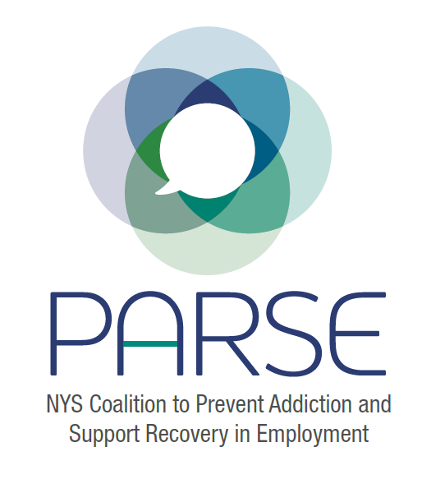
PARSE Steering Committee Agenda
7.20.2022
- Brief introductions - Allison Weingarten, Sarah Toledano, Ben Riker, Emily D’Angelo, Jonathan Rosen, Sue Martin, Kristen Chalmers, Cristina Dyer Drobnack, Kitty Gelberg, Jennifer Donadio, Nydia Hill, Dan VC.
- Opioid Settlement Board discussion - review of the 4th and 5th meetings of the opioid settlement board. Found out that counties have already gotten their allotment from the settlement, but they are not bound by any recommendations of the board for how to spend their money. Encourage us to reach out to the local health department, AG’s office, mental health offices, to see how they plan to spend that money. A person to reach out to is Ryan Gregoire, Legislative Director of NYSAC. Ben and Cristina follow up to contact the legislative director. Focus more locally preferably because counties that have more punitive views on SUD, will spend the money more punitively.
- Discussion regarding priorities: symposium, RFW legislation, resources -
- Since we last spoke:
  - Opioid Settlement Fund Advisory Board Letter - We need funding for the symposium. Maybe there is money in the Opioid Settlement Fund for funding a symposium and to prioritize this RFW program in some capacity. It’s an introduction to who we are and what our goals are and includes our ask.
  - Letters to NYS DOH, NYS Legislators, and Governor’s Office - Asking for funding, and their help getting the state agencies on board. The plan for the assembly is to reach out to LAPAA to work with them to develop this model state legislation. Assembly side folks to reach out to: Assemblyman Billy Jones (Sue has a connection). Follow up with Allan Clear - Allison will do this.
  - Meetings with OASAS and ARC - Had a great meeting with ARC. Kyle Wilber has been on a couple of our calls. He is from the north country and they run a back to work company. OASAS says that the conversations are happening internally but they are not ready to take it right now. Unless there is funding attached to it, possibly through the Opioid Settlement Fund?
- Interns for next year - unified plan and a meeting with the three folks who are having interns to discuss how to divide the work - sarah will organize this.
  - Siena NExT Students (Sarah Toledano) - Interested in pursuing the research angle here and recreating the study that Julie Dostal’s team took part in and adding information from folks
  - NYSACHO (Cristina Dyer-Drobnack) - Development of legislation about 10 hours a week on this for the group.
  - FOR-NY MSW Intern (Ben Riker) -
  - NYS DOH (Allan Clear) -
- Break into workgroups/assign notetaker and speaker/create action plans- date for upcoming meeting, email group (20 mins)
  - Labor Outreach and Training - Ultimate goal is to get the AFL-CIO. The way to do that is to get the affiliates involved. Developing outreach material and then send those emails out or gather those contacts. Make the road NY. Dan will begin by making up a list of the different coalitions that he is a part of and putting some contacts down for those groups. Strategy for COSH groups, clinics, social justice coalitions, unions, etc. Subcommittee to convene. Jeanette, Kristen, Dan, and Jonathan. Sue will reach our to Hire a Vet to possibly join the coalition.
  - Employer Outreach and Training - Employer group. We need to follow up with the Business Council. Allison will circle back around. We could pull together a meeting with the friendly employers we have currently and strategize for the webinar with the Business Council.
  - Symposium/Conference Planning - Melissa suggested that she is interested in fundraising efforts for the conference (businesses who are interested in this initiative to sponsor?) Need to get funding for the symposium. Two day event. 250 participants or more, all different types and kinds of folks. Hybrid two day.
  - Funding Committee - Rachael suggested creating a budget for this. Ben and Sarah will put together a rough budget and then go from there. This may be lofty, but it might be a worthy effort to take a look to see if this is a funding opportunity: https://debeaumont.org/made-for-health-justice/call-for-applications/
- Share plan with rest of steering committee, discussion (20 mins)
- Date for next steering committee meeting (5 mins)
  - Next Coalition Meeting - Thursday, August 11th. Next steering committee meeting - Wednesday, August 17th. Thanks to our reporter, Kristen!

