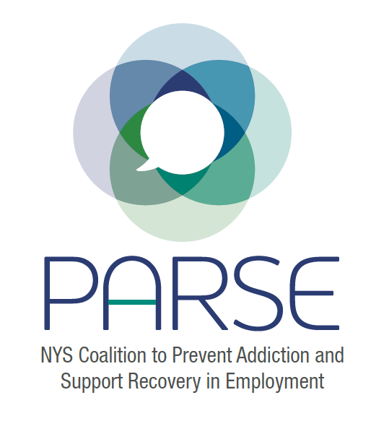

PARSE Committee Meeting Notes
March 28, 2023

Moderators:
Allison Weingarten, Clearinghouse for Worker Safety and Health Training
Jonathan Rosen, Clearinghouse for Worker Safety and Health Training
Dr. Angelia Smith-Wilson, Executive Director of Friends of Recovery – NY
Sarah Tolendano, Assistant Director of the Center for Academic Community Engagement at Siena College, NeXT program

RFW Highlight: Ken Daly, Gino Macchio Foundation: Put Recovery to Work, Recovery Friendly Workplace, Long Island
Ken Daly:
Background of the Gino Macchio Foundation (GMF): The GMF’s two main thrusts are
- Recovery Friendly Workplace initiative at GMF – Recruit businesses, small local towns and municipalities to become Recovery Friendly Workplaces.
- Recovery to Work initiative – removing barriers to work by offering “scholarships” to individuals in recovery by providing funds for transportation, housing, proper clothing, and other essentials to maintain employment. GMF has had five individuals employed in the first year of the initiative, one year later all five are still working. One of the five continues to work for the foundation.
Funding Sources:
Restricted Funding is used just for the projects funded by government grants that GMF receives. These projects ask for very specific things.
Unrestricted Funding comes from fundraising events, such as galas, comedy nights, fishing trips, and other community events. We have precise goals for what each event will fund. Staffing is also funded through unrestricted funds.
Business model: GMF focuses on one aspect of the substance use disorder cycle: Recovery. GMF has chosen the Recovery “Silo” for maximum focus and impact for those it serves.
Hopes that RFW Legislation will create resources that will allow all these programs and efforts to work in concert with one another.
Annette from GMF to provide support. Terence to recruit and work with Recovery Friendly workplaces.
Jonathan Rosen: Closing the loop, we are hoping legislation will create resources that will allow all these programs and efforts (Prevention, Treatment, and Recovery) to work in concert together.
Allison Weingarten: Next part of the meeting’s focus is bringing the coalition together on the importance of language, humility and growth. Allison Weingarten introduced Jeanette Zoeckler of Director of Preventive Services at the Occupational Health Clinical Center, SUNY Upstate Medical University, Syracuse and Dr. Angelia Smith-Wilson.
Jeanette Zoeckler: Offers background on how today’s focus on the importance of language came about. Jeanette met with Allan Clear, Director at the Office of Drug User Health at NY State Department of Health. Allan oversees the SUDOR (State Unintentional Drug Overdose Reporting System) database. The goal of the meeting was to gain information related to overdose deaths in specific occupational fields and industries. The meeting exposed a better need for understanding of the various terms and acronyms used in the harm reduction and recovery-based fields.
Angelia Smith-Wilson: Employers are concerned about workplace safety on the recovery continuum-asking individuals what healthy recovery looks like when it does not look like abstinence. Angelia brought up the words Amnesty, Continuum, and Harm Reduction pointing out that we need to inform people on what these terms mean to employers and the professionals in the field. What does healthy recovery, safety, and harm reduction look like in the workplace. How is it defined? We need to allow for amnesty- one community may find some language offensive if not familiar with the language used. What we say to each other should not be taken as a statement of malice. By allowing for amnesty, people can reach a better understanding of one another by recognizing similarities and where we align. What we want at a work site is safety. Employee and employer want safety. We need to come together to create a common language to improve our level of understanding of one another.
Allison Weingarten: Thanks Angelia and recommends break out groups in upcoming meetings to study Harm Reduction, what it is and where it fits in the workplace. Allison suggests Danielle Ompad, Professor, Global Public Health · Urban Initiative at NYU to join this group. Allison adds that she believes the NY State Department of Health will be a major contributor to the December symposium.
Julie Dostal, Executive Director of LEAF Council on Alcoholism/Addictions, Inc., leads the committee members in a “Scattergories” type of activity exploring the definitions behind a wide variety of acronyms for organizations and commonly used phrases used when discussing substance use disorder. Five teams were tasked with identifying an acronym and coming up with the correct full name of the acronym. In summation of the exercise, Julie Dostal notes the large number of acronyms and suggests we compile an index of all acronyms to improve communications and share the resulting glossary.
Updates:
Kristen Chalmers, Licensed Master Social Worker at University of Rochester Medical Center is meeting with DOS (the Department of State) and ARS (US Department of Agriculture-Agricultural Research Service) and the need for SUD impact studies on Appalachian counties. Also, a reminder that the December 4 & 5 symposium is looking for qualitative interviews and have had discussions about marketing and sponsorships.
Steering Committee Report: Kristen Chalmers: Find notes here: https://drive.google.com/drive/u/1/folders/1HIFbXGr4zLWb2wC9xC_J_Tq5x8lwtXdZ
Legislative Update with Jonathan Rosen:
Jonathan has been talking to Senate and Assembly subcommittee chairs to bring about legislation but looking towards a 2024 bill in order to get better funding for outreach, certification, and job training. We need employer organizations to come aboard to help this pass. We need this to be a Governor’s bill. Need to have a strategy meeting just on this topic. Invite all including legislative committee to map out a strategy.
Symposium Funding: Had talks with ARC’s Lauren Wood. Kyle Wilbur will be putting in writing requesting funding, “could funding be used to fund employers to come to the symposium”. However, suggests we need to be careful we are not double dipping when funding these attendees. George Korchowsky notes funding for these attendees needs to be provided by matched funds in order to prevent double dipping of funds. Existing grantees could put in 30% for doing outreach, attending event. Can also be in-kind.
Jeanette is taking the lead to gather a qualitative study so we can cite data and use the information in outreach and funding appeals. We want to inform and support the policy. What we need, how policy can be shaped and formed. May be publishable in peer review. Jonathan suggests gathering “vignettes”, testimonial videos about recovery from SUD.
Anyone wanting to participate in the qualitative research which will be conducted at the symposium, please let Jeanette know here or by email (zoecklej@upstate.edu). It is under development and all will be involved in the design and in conducting interviews/focus groups/analysis. Anyone who has ideas for our research questions can share them with Jeanette, too.
Upcoming Meetings:
April meeting will be skipped. Next full coalition meeting is Tuesday, May 16 from 3:00 to 4:00pm.

