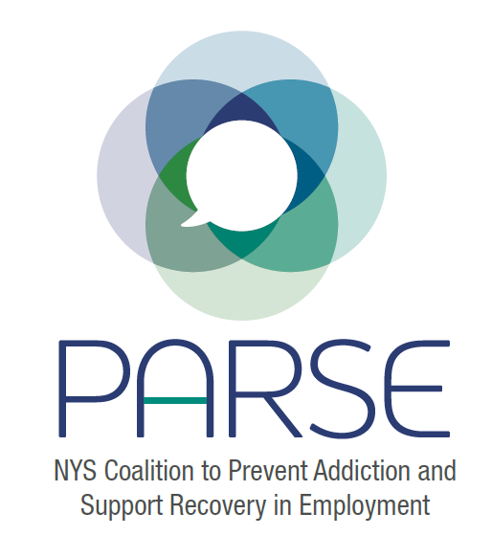
PARSE Steering Committee Notes
10.26.2022
Brief introductions
Field Work
- Eric reaching out to SUNY Downstate, Paul Landsbergis paul.landsbergis@gmail.com \
  - Looking to work on communications materials and toolkit
  - Needs to know “who is sponsor” for outreach
  - Needs a blurb, what this is about (Allison)
- Jeanette- reaching out to her public health and Social work interns
Podcast
- Eric asking if PARSE could be a guest speaker here: https://hsi.com/podcast/accidentalSafetyPro
Outreach
- Jeanette utilizing OHCN outreach lists
- Present to OHCN Quarterly meetings, advisory boards
- We have an outreach list in the Google Drive of almost 300 people
Symposium- Planning
- What would it cost to hire an events coordinator – create budget (Allison)
- 1 day versus 2 day? “Pre conference with “just us 50”
- How many people – 250-300?
Fundraising and Sponsorship
- John Rork creating outreach doc
- Which org will be fiduciary?
  - FOR-NY for OASAS funding
  - NYSACHO for DOH funding
- Sometimes there is money in May/June but we cant predict that
Strengths and Weaknesses
- At some point soon we need to identify where our strengths and weaknesses are. How can we address those weaknesses?
Roles
Steering Committee Members | Work in next Couple weeks
Allison W
Allison W and Rachel L | Work on Budget
Julie, Kristen, maybe Kitty and Jeanette | Work on Agenda
John R | Sponsorship ask letter
Eric | Outreach to SUNY downstate, field experience (communications materials and workplace toolkit), reaching out to podcast
Ben | Work with Cas on event registration page
Jeanette | Looking into public health students, coordinate network list, contacts
Alison Young | Conferring with Stacy; working with employers; testimonials
Dan | Meet with Jonathan and Allison about labor outreach
Date for next steering committee meeting, next steps – November 23

