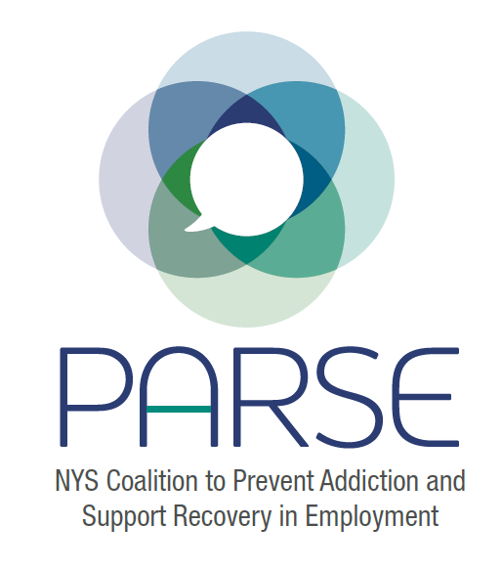
PARSE Steering Committee Agenda
11.23.22
- Brief introductions
- Discussion regarding priorities: symposium, RFW legislation, resources
- Since we last spoke:
  - Email to NYS Executive Chamber – Jihoon Kim
  - Legislative group update
- Survey Monkey Results (discussion)
- Responsibilities, job descriptions doc (discussion)
- Split into groups based on responsibilities doc, discussions, action plans
- Share plan with rest of steering committee, discussion
- Date for next steering committee meeting, next steps – Dec 14
Modest registration fee
Send letter to agencies by the end of next week
Have a brief explanation for who we are- new legislative leaders- let us know if others want to participate
Mashaal Sen. Ramos; Kelles moving to SUD
Ali – Next steering committee, will meet with grant partners ask for group is to connect with Recovery Friendly Workplaces, gain some testimonials, visual. Connect with Anna Kelles’ office
Ben- focusing on Stand Up for Recovery Day; get legislative meetings scheduled. 4-7 minutes speaking opportunity, identify someone to speak to employment – share with coalition and how it will benefit all
Eric- work on the data, interest on research
Nydia – Ideas for Labor

