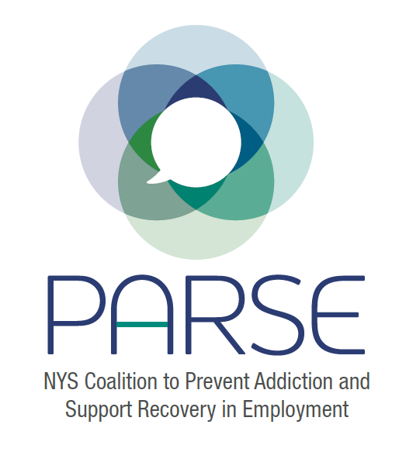
PARSE Steering Committee Notes
12.14.22
- Brief introductions
- Since we last spoke:
  - Email to NYS Executive Chamber – Jihoon Kim
    - Commitments from OASAS: Maybe $15K
    - Commitments from DOH: Maybe $20K
    - Reaching out to all agencies after formal commitment from OASAS and DOH
FOR-NY will be able to dedicate more time and energy after Jan 1, part of deliverables, will have financial stake
Grant application: https://elevancehealth.foundation/userFiles/uploads/docs/grantseekers/EH_SUD_RFP_11-2022.pdf
Sarah will send out a plan for grant application by Friday afternoon
  - Policy group update
See minutes in google drive: https://drive.google.com/drive/u/1/folders/1eZCHxUN8LQ80rwneE38_wvYPkICUNc9j
Regarding Peer Employment-Certification: Sean in Jamestown met with HR and Union represetnatives at a couple of factories in Jamestown to gain their support in doing worker training. Made short presentations that resulted in several workers reaching out privately for support. Told HR that they got calls but kept the names confidential and anonymous.
Potentially could collaborate with WNYCOSH and the International Unions. Maybe USW and IAM.
  - Research group update
Letter- sent to NYS DOH offering to collaborate on research regarding overdose fatalities by industry and occupation.
Ben suggested: setting up a call with OASAS to ask for research funding to be part of RFPs coming out of Settlement dollars.
  - Education and Training Group update
First meeting – Friday December 16 at 10 am. Several members asked to be invited.
- Other updates:
Symposium: Need to have another meeting on agenda. Funding is a key the issue, get a sense of what our parameters are. Looking at preconference institute, full one day conference. Don’t know that that is the finalized decision. Can start plugging in the program and talk about specific speakers. Backup plan- having a registration fee so we can move forward at setting the agenda.
What we want to accomplish- who we want to impact
- Center around folks with lived experience- who found success. Put them front and center
- Employers
- Unions
- Safety and Health
- Trade schools
- Culinary arts, restaurant workers
- Construction unions and workers
- Recovery and Prevention organizations
- Policy makers
Marketing: Need marketing plan, sponsorship sign up page we can start to add money. Materials printed. Ben will look into. Sarah will send out an email by Friday.
Website: Sarah will work on the website.
Funding will likely go towards conference coordinator
Stand Up For Recovery Day as an opportunity to market, need to order marketing materials. Need to establish a group to work on this.
- Date for next full coalition meeting: Jan 9; Date for next steering committee: Feb 15

