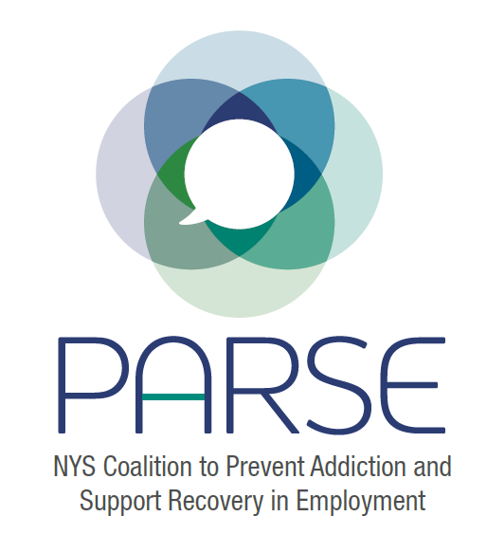
PARSE Steering Committee Notes
2.15.22
- Brief introductions
- Since we last spoke:
    - Symposium: Budget Estimates; Dates, location
Desmond Hotel, Dec 4-5; Updated budget and sent to Allan Clear.
Ken Daly offering administrative staff member to help part time.
    - Commitments from OASAS
Small but important to have their buy in
    - Commitments from DOH
Jonathan, Angelia and Allison met with Allan Clear from DOH- he is optimistic about obtaining funding. At this request, Jonathan sent in letter with budget request and draft symposium agenda.
    - Reaching out to other agencies
Discussion around waiting for funding to come in before reaching out or reach out now with hopes that funding will come in. Both ideas were considered. Consensus reached to wait for funding to come in.
Jeanette and Sarah to work on outreach to Workforce Development Institute. Jonathan has a relationship with Brian Williams in Rensselaer and will be in touch with.
  - Leadership of PARSE. Need more help in basic organizing of meetings, outreach, and planning. Communication from committees back to steering committee and main group.
Ken Daly- offer to support us with administrative staff. Angelia is also planning to communicate with OASAS about the time and energy needed to support the coalition.
  - Policy/Legislation group update
Jonathan was able to share and receive feedback from Richard Winston, an experienced labor lobbyist. A meeting has been set with office of Senator Fernandez, new chair SUD committee on Friday 2.17.
  - Research group update
Meeting coming up 2.27 with NYS DOH
  - Education and Training Group update
Carrie Dunn-Herrera unable to make call. The symposium draft agenda has been updated and was sent to the steering committee.
Daniel Vaughan-Cherubin is leaving NENYCOSH for a new job with Hunger Solutions. We thank him for his time, commitment and input to PARSE and wish him all the best. We hope we can reconnect soon and continue working together.
Date for next full coalition meeting: Feb 23; Date for next steering committee: March 23

