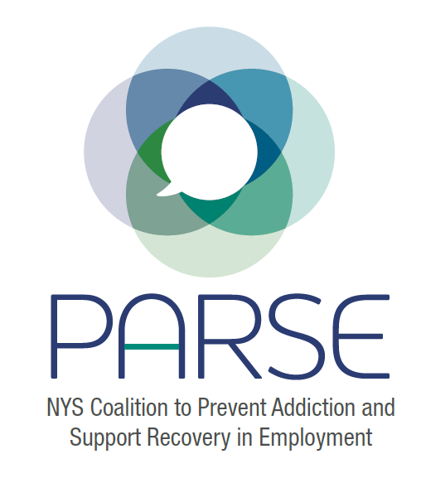
PARSE Steering Committee Notes
8.17.2022
- Brief introductions
- Symposium
- Sarah- budget- winded up with more questions than answers
- Questions- Continued Education Credits? How does that impact cost? What could student pricing be? Could we give a university/recovery center rate? (For example, $500 for 5 participants to get credit)
- Credits we could offer: CPP, CSAC, LMHC, LMSW, Nursing, CRPA, MD, Law, HR, SHRM
- Proposed dates- April 3, 4; May 8, 9 and June
Janet Womachka: Recently had conference at Saratoga Hilton/City Center. 300 online participants; 500 on site. Did full hybrid platform, virtual participants could visit vendors – Just the virtual portion cost $75,000
Hotel- Saratoga Hilton/City Center – required contract with CMI (AV)
8 break out rooms, 1 grand plenary room – On site cost = $126,000 (had own laptops, microphones)
Does not recommend Saratoga because of cost
Met with OASAS a few weeks ago. Now the are asking us what we need.
- Recommendation: set up three budgets- 1 is initial ask- actually what it will cost, do not hold b ack on costs. 2 and 3 show ways we could raise money, charge participants, etc.
- General consensus is to do 1.5 days
- Start with hearts and minds, move towards policy development
  - Will depend on whether we have legislation introduced by then
- Looking at Desmond hotel
- Since we last spoke:
  - Opioid Settlement Fund Advisory Board Letter – need to follow up
  - Letters to NYS DOH (need to follow up), NYS Legislators (meeting scheduled), and Governor’s Office (looking into dates)
- Interns Update – Sarah, Cristina – coming up with job descriptions
- Eric- What can we do between meetings?
- Work on agenda
  - Rachael: Should we do a call for speakers or just choose?
- Work on budget
- Date for next steering committee meeting, next steps – Sept 21 (5 mins)

