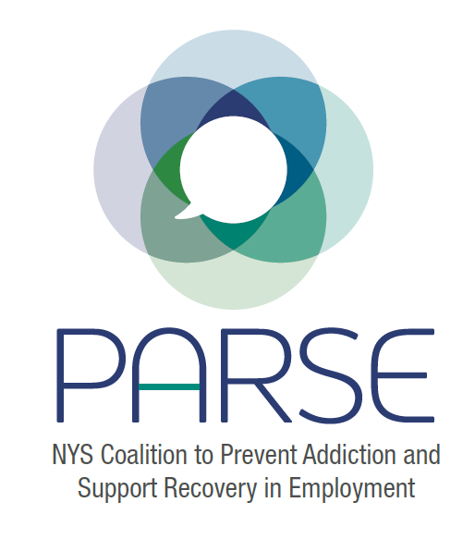
PARSE Steering Committee Notes
9.21.2022
Introductions
- Problem gambling- appalling the amount of revenue and the budget for problem gambling services.
Legislation
- Idea to Introduce legislation for 24-25 cycle. Use symposium to get people excited. We have LAPPA. LAPPA will create something comprehensive and we can adapt to our needs.
- Let’s work smarter, not harder.
Break out groups: See Attached
- Draft Symposium Agenda
- Labor/Employment Outreach Doc
Next Steps:
- Kristen Chalmers would love to present work-stress and resiliency to any worker group (at no cost as she is funded by a grant). She can tailor each presentation to the individual worker group (ex- when she shared with the Operating Engineers, she tailored it to their work environment/stress, etc.). (see flyers attached)
- Labor and Employment outreach list (Sarah T adding to Google Doc)
- Keep talking to local counties/opioid settlement dollar distributors
- Ideas for breakouts during Oct 3 meeting
- Karine assisting to reach out to Governors Office of Employee Relations

