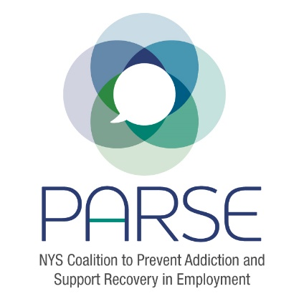
PARSE Steering Committee Notes
Wednesday June 7, 2023

Moderator:
Allison Weingarten, Clearinghouse for Worker Safety & Health Training

Allison:
- We need to increase the focus of the Steering Committee on the symposium agenda.
- We need to move ahead on email blasts to promote the symposium to the public.
- We need to recruit higher level speakers to garner higher levels of sponsorships.
For Dinner portion of the symposium: Recommends reaching out to potential speakers such as Governor Hochul, NYS DOH Commissioner James V. McDonald, OASAS Commissioner, NYS DOL Commissioner, Senate Chair Nathalia Fernandez (Chair, Alcoholism and Substance Use Disorders Committee). Had a promising meeting with Congressman Paul Tonko.
For the next day agenda recommended speakers are Danielle, Sam Lewandowski and Angelia, among others.
Sarah Toledano suggests a panel instead of individual speaker in the dinner portion of the symposium, but discussion ensues pointing out that it may be best to allow VIP speakers to speak individually.
Carrie Dunn-Herrera suggested spotlighting key speakers throughout the duration of the symposium instead of scheduling them to speak one after the other in succession in a short time frame. Cristina to follow up on this.
PARSE Symposium Finance Outreach: targeting agencies for outreach including NYS Council of Mental Hygiene Directors, MVP Healthcare, Empire Blue Cross/Blue Shield, Emblem Health, DOH, OASAS and union leaders.
Mike Carpenter (President, The Northeast Group) asks what are the sponsorship levels; what do business sponsors get, is it a table, what is the recognition?
Allison: projected cost for the dinner is $20,000, and $3,000 snacks. Tickets will be $225 for the full symposium. Also, sponsorships by organizations such as the Department of State would have their own people come so the sponsorship could reach $5,000 per organization. Good news, OASAS is giving $5,000 towards the symposium.
Other suggestions for sponsors include Brenda from OASAS, head of the Recovery Bureau to see if they can sponsor individuals from each OASAS funded recovery center to attend symposium.
Carrie recommended Stephanie Campbell and Cortney Lovelle as captivating speakers with lived experience.
Allison: We need to craft email outreach to sponsors and then share results in google drive to track progress.
Allison poses question: Should we invite speakers to coalition meetings to avoid replicating the steering committee meeting and keep people interested and to differentiate full coalition meetings from steering committee meetings?
Eric Persaud agrees that inviting speakers to full coalition meetings could increase attendance and engagement. Kristen, Sarah, and Carrie all agreed.
Possible speakers for upcoming full coalition meetings:
- Department of Labor official – Allison to follow up
- Sharon Beard, Worker Training Program – Eric to follow up
- Cortney David NYS Council of Mental Hygiene Directors – Cristina to follow up, discuss how the Opioid Settlement funds are being dispersed and what specifically does it fund.
Eric notes that from last research committee meeting Sarah created a google form to share study results. They are gathering qualitative and quantitative information. Eric and Sarah have created a survey plan to send to PARSE members soon. Eric and Jeanette will then analyze the results.
Kristin suggests we send out an email to coalition members asking what areas of service they work in, such as prevention, treatment, harm reduction or recovery.
Carrie set date for workforce development meeting – June 15 from 12-1pm.
Allison notes during these meetings we need to focus on education and training, differentiating the areas of focus involved in multiple aspects of education and training.
In closing, Allison asked for volunteers to draft outreach letters, one targeted to recruiting speakers, the other to solicit funding from sponsors. Allison will draft the letter to funders, Kristin volunteered to draft the letter to speakers.
Allison expects the PARSE website to be up by Friday June 9. Having the website will help to increase awareness about the symposium reaching potential speakers, sponsors, and symposium attendees.
Cristina will look at the symposium agenda to see where to sprinkle the speaker’s time slots throughout the 1 ½ day program. Cristina will coordinate with NYCMHD either speaking at the next coalition meeting or recruiting another speaker on June 15.
Kristen offered to be a guest speaker at future PARSE coalition meetings in a pinch if other guest speakers cannot attend.
Carrie offered to speak at the September meeting.

Next Full Coalition Meeting is June 15

