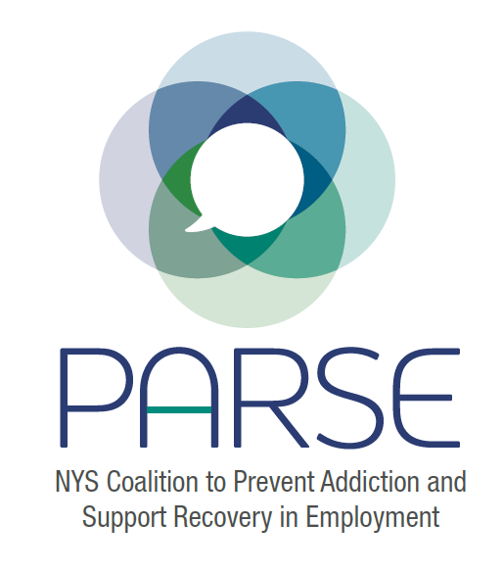
Steering Committee Notes 6.29

Overview of:
- Outreach List (see attached)
- Letters to Allan Clear (DOH; Jihoon Kim (Governor’s Office); Senators Ramos and Harckham (see attached)

Discussion of Merger between OASAS and OMH – some bills to move this forward with money attached

Recent NYT Article: https://www.nytimes.com/2022/06/24/opinion/addiction-overdose-mental-health.html?campaign_id=39&emc=edit_ty_20220624&instance_id=64886&nl=opinion-today&regi_id=79616458&segment_id=96652&te=1&user_id=05051aae80eb19ab1b5338052b1de143

Developing Financial Resources-
- Ben submitted grant. Keep eyes peeled for opportunities

Other opportunities:
- United Way- encourage everyone to look out for grant
- ARC- fantastic resource – meeting scheduled for July 8
- Important to diversify funding
- Can we get resource support from state agencies/governor’s office
- If this is a scientific conference (or has a significant scientific part)… NIH has conference grants: https://grants.nih.gov/grants/guide/pa-files/PA-21-151.html
- Health Foundation? - https://nyhealthfoundation.org/what-we-fund/special-projects-fund/
- https://healingcommunitiesstudy.org/
- https://cabrinihealth.org/grants-programs/ (Ana Almanzar)
- HRSA

Columbia University – Healing Communities Study (NIDA identified) Money is going to community level and community is deciding what they want to fund
- Increase Naloxone
- Get into Medications for Opioid Use Disorder
- Reduce Stigma

Employer Outreach:
- John Rork- Chamber of Commerce – can dedicate time to hit them over the head, pots of covid money, marketing, national chamber of commerce- second chance employment. John utilizes boots on the ground approach.

Jeanette and Kristen- could talk with the social workers/will speak with Alecia Fletcher from DOH

Send out
- Notes
- 1 pager
- New Logo
- North Carolina Toolkit

When we develop toolkit, Must be as user friendly as possible

Nydia Hill question about giving resources to people who do not speak English- right to get Occupational Safety and Health information in the language they understand.

Connect with Nydia with
- NENYCOSH - dvaughancherubin@nenycosh.org
- Alex Dell, Esq, workers' compensation lawyer to help with injured worker who was fired.

